**Technical Analysis**

**Program : Multi Finance**

**Name : DoniAntoro**

1. **ERD**

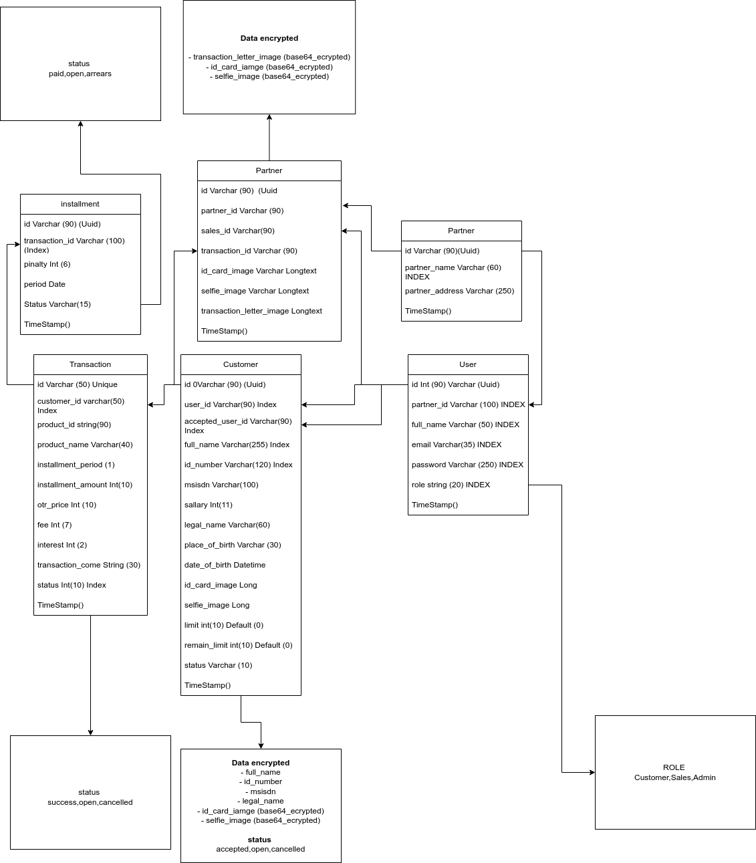

1. **Sequence Diagram**

**\*Note all of prosses in system , every input has a validation**

* 1. **Authentication**

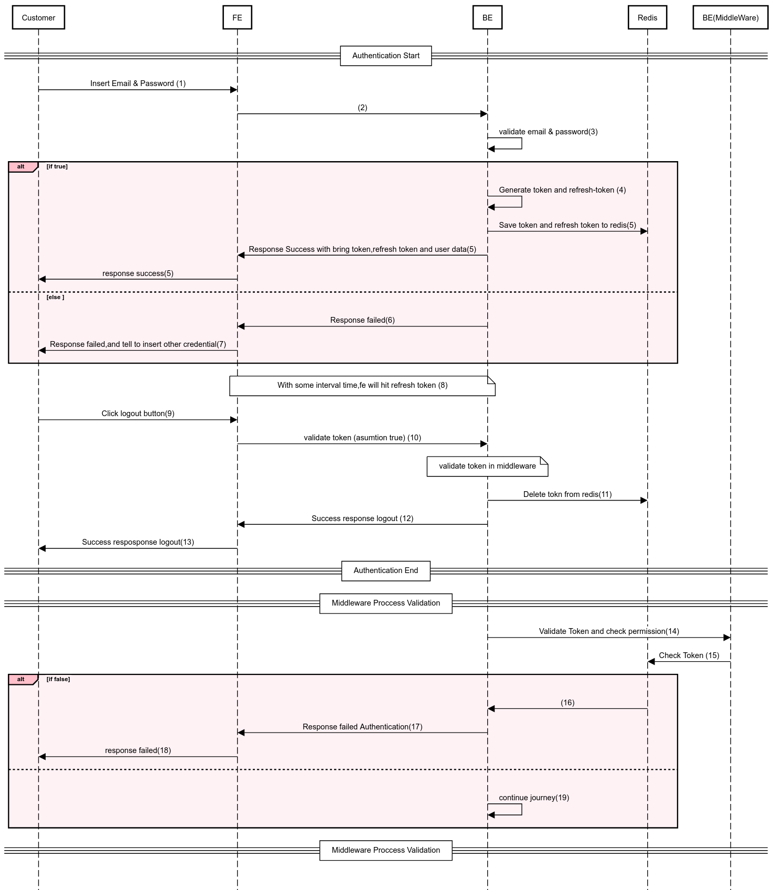

* 1. **Apply Application**

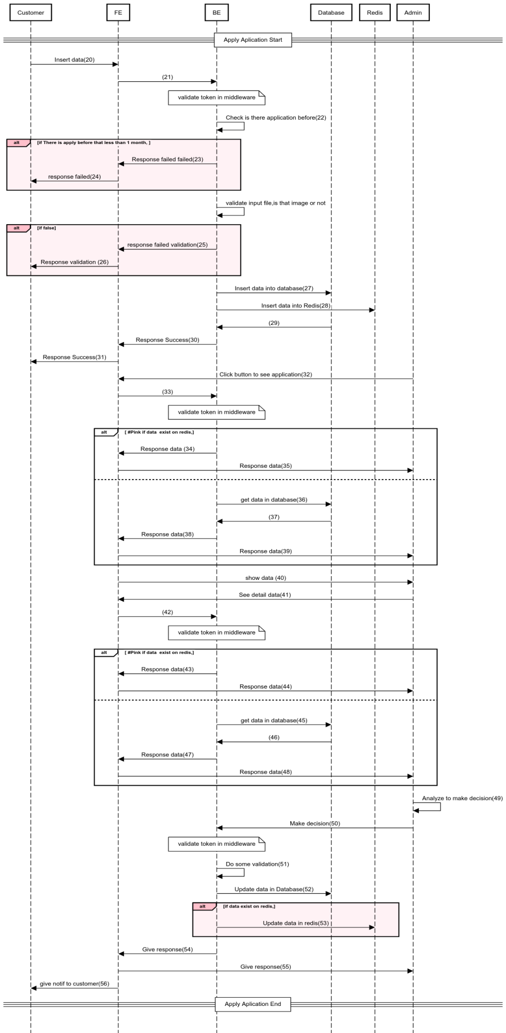

Note : Due to limitation time , Proccess number 28 that insert data to redis cannot be implement.But ,Proccess number 53 that update to redis already implement

* 1. **Transaction**
     1. **Transaction offline**

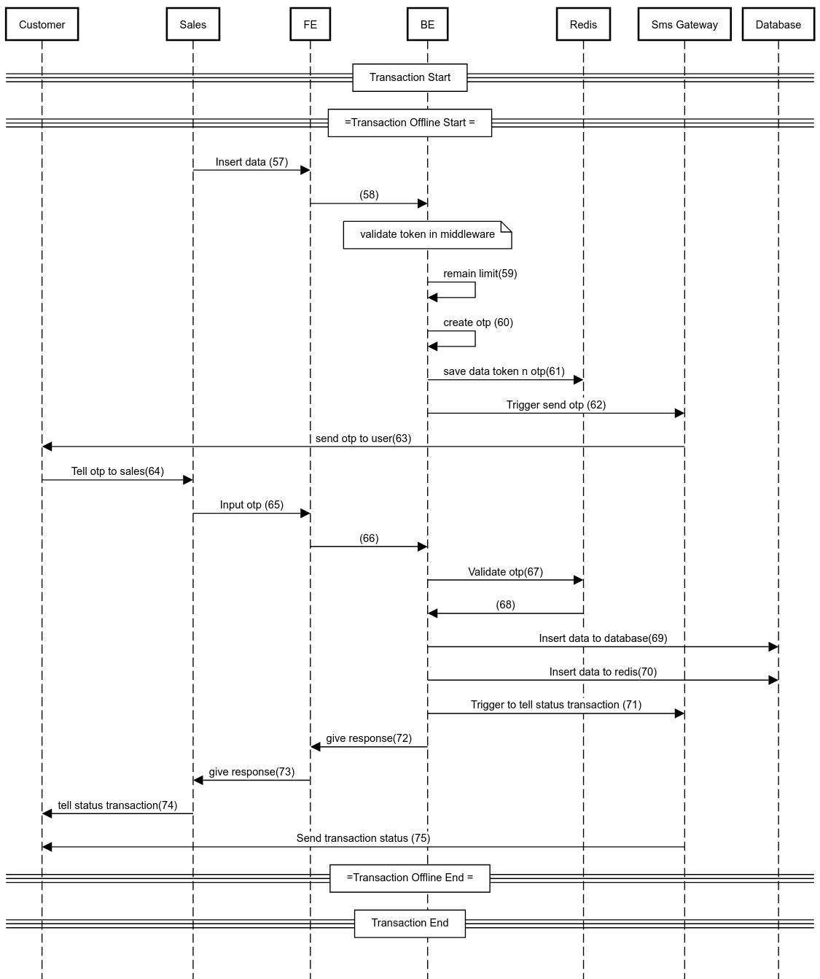

Note : Due to limitation time and resource , Proccess number 59-68,71 and 76 that insert data to redis cannot be implement

* + 1. **Transaction Online / Markeplace**

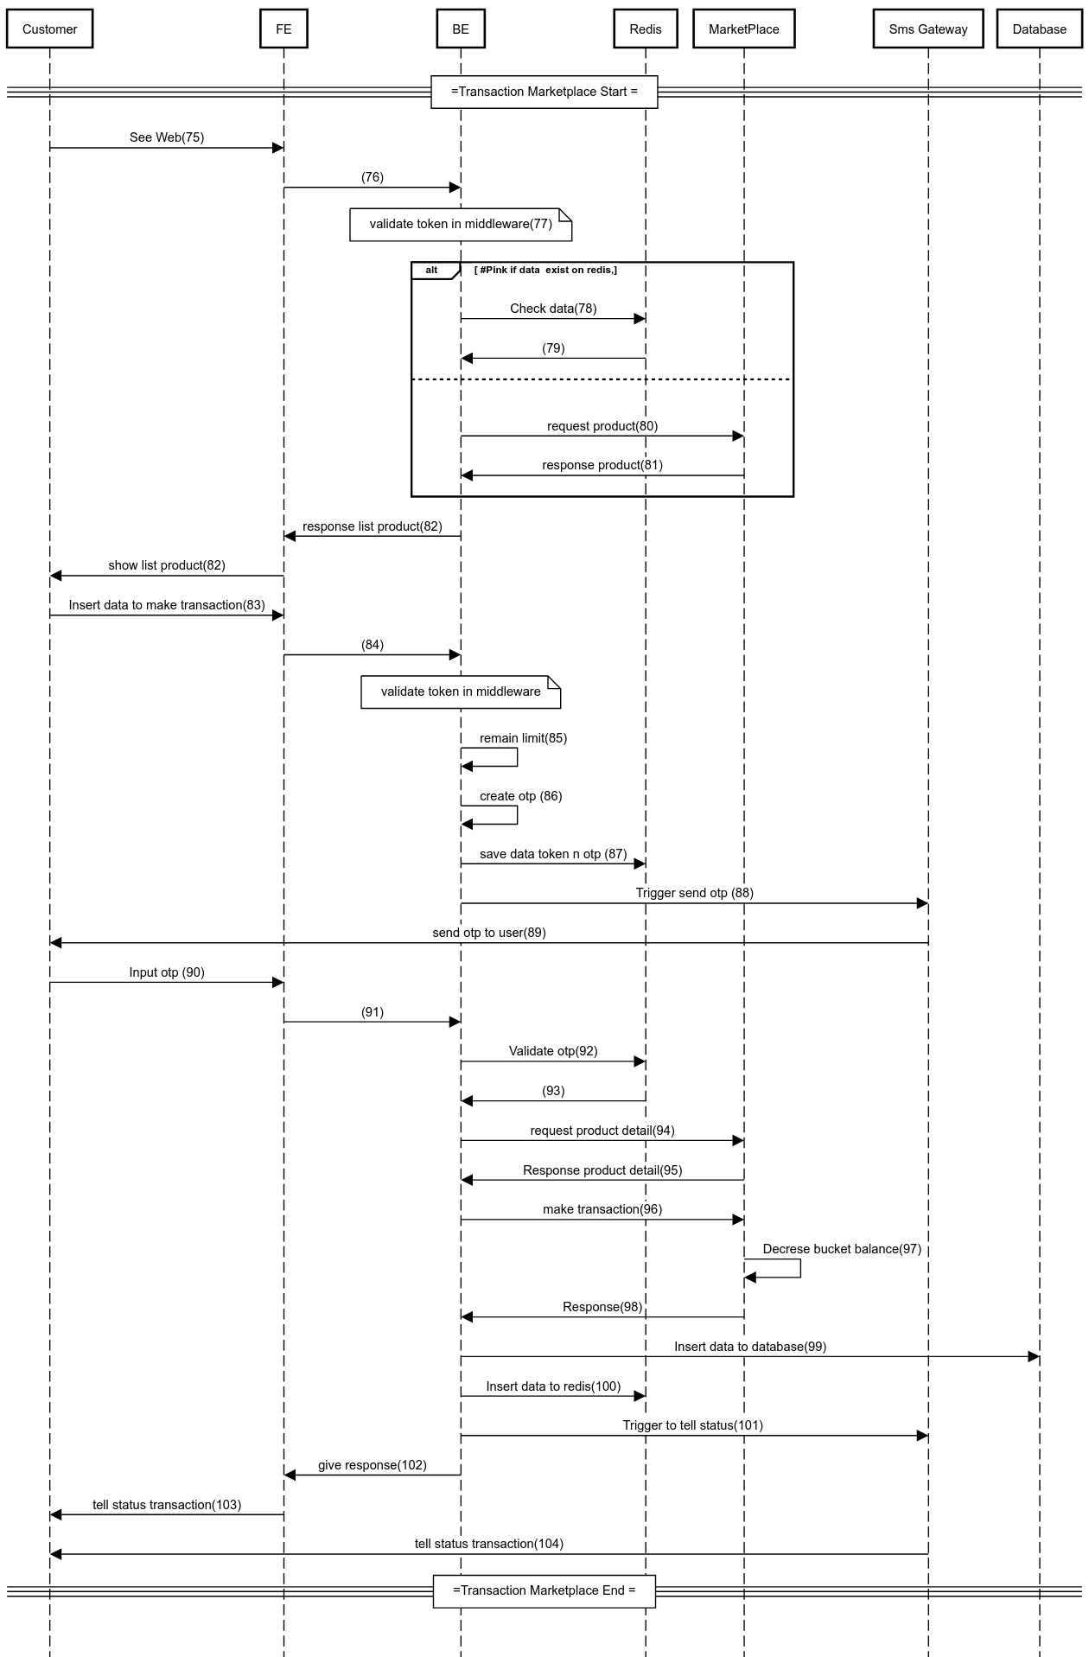

Note : Due to limitation time and resource , Proccess number 86-93,100,101 and 104 cannot be implement

* + 1. **See Transaction Data**

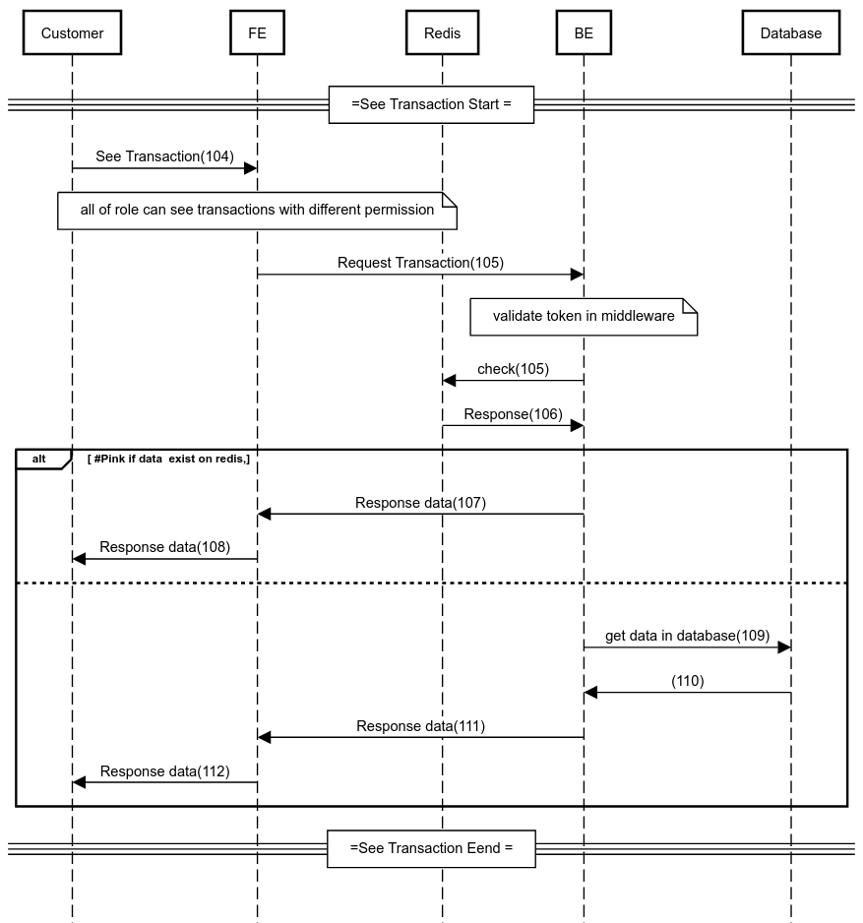

Note : Due to limitation time and resource , Proccess number 107 and 108 cannot be implement

1. **Prevent Attack**

to prevent TOP 10 OWASP, the system already implement ssl, mapping error,loging and use orm